Exercise3_answers.R

2022-12-11

#Exercise 3 Answer Key  
library(FSA)

## ## FSA v0.9.3. See citation('FSA') if used in publication.  
## ## Run fishR() for related website and fishR('IFAR') for related book.

library(ggplot2)  
library(tidyr)  
library(dplyr)

##   
## Attaching package: 'dplyr'

## The following objects are masked from 'package:stats':  
##   
## filter, lag

## The following objects are masked from 'package:base':  
##   
## intersect, setdiff, setequal, union

#1. Generate a vector of percentage of fish in 10mm length intervals using the   
#“BluegillLM” data set from the FSAdata package.  
BluegillLM <- FSAdata::BluegillLM   
  
#Add a length category column  
BluegillLM$lcat10 <- lencat(BluegillLM$tl,w=10)  
  
#Check data to confirm  
headtail(BluegillLM)

## sernum sl fl tl wght lcat10  
## 1 100 126 152 157 92 150  
## 2 110 124 150 153 88 150  
## 3 120 118 140 149 77 140  
## 98 1070 116 141 147 64 140  
## 99 1080 113 140 144 64 140  
## 100 1090 105 128 133 49 130

#Create a length frequency table  
#Using the xtabs function, requires the column name   
#with length category and the dataset  
BLGFreq10 <- xtabs(~lcat10, data = BluegillLM)  
#print frequency table  
BLGFreq10

## lcat10  
## 50 110 120 130 140 150 160 170 180 190 200 210 220 230   
## 2 1 5 11 20 20 10 7 2 3 4 8 6 1

#Percentage of fish in each interval using the   
#prop.table() function  
BLGPer10 <- round( prop.table(BLGFreq10) * 100 , 1)  
#print proportion table  
BLGPer10

## lcat10  
## 50 110 120 130 140 150 160 170 180 190 200 210 220 230   
## 2 1 5 11 20 20 10 7 2 3 4 8 6 1

#2. Create a length frequency histogram of total length (tl column) using the “BluegillLM”   
#data set from the FSAdata package.  
  
#A histogram can be useful to visualize   
#length frequencies  
ggplot(BluegillLM, aes(x = tl)) +   
 geom_histogram(breaks = seq(from = 50 , to = 230, by = 10),  
 fill = "orange", color = "black")

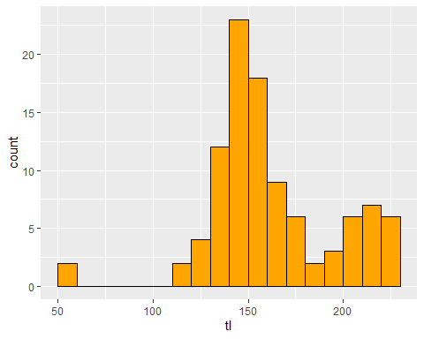

#3. Create a frequency table of Bluegill PSD size groups using the “BluegillLM”   
#data set from the FSAdata package.   
  
#Assign length category to each fish to the   
#Largemouth Bass data frame  
#Load the BluegillLM data set  
BluegillLM <- FSAdata::BluegillLM   
  
#First we need to pull out the Largemouth Bass   
#length categories  
blg.cuts <- psdVal("BLuegill")  
  
#Filter based on tl greater then stock length.  
#This eliminates fish less than stock length  
#and add the length category column  
BLG_SS <- BluegillLM %>%  
 filter( tl >= blg.cuts["stock"]) %>%  
 mutate( gcat = lencat(tl, breaks = blg.cuts,  
 use.names = TRUE))

headtail(BLG_SS)

## sernum sl fl tl wght gcat  
## 1 100 126 152 157 92 quality  
## 2 110 124 150 153 88 quality  
## 3 120 118 140 149 77 stock  
## 96 1070 116 141 147 64 stock  
## 97 1080 113 140 144 64 stock  
## 98 1090 105 128 133 49 stock

#Calculate a frequency table across size groups  
xtabs(~gcat, data = BLG_SS)

## gcat  
## substock stock quality preferred memorable trophy   
## 0 37 42 19 0 0

#4. Calculate the PSD-Q and PSD-P of Bluegill using the BluegillLM dataset   
#from the FSAdata package.  
  
#Calculate all PSD-X values and 95% Confidence   
#Intervals. Requires length column, data set,   
#species, and what type. Types available are   
#incremental (e.g., Stock to Quality) or  
#traditional (e.g., Quality, Preferred, Memorable)  
psdCalc(~tl, data=BLG_SS,   
 species = "Bluegill",   
 what = "traditional")

## Warning: Some category sample size <20, some CI coverage may be  
## lower than 95%.

## Estimate 95% LCI 95% UCI  
## PSD-Q 62 50 74  
## PSD-P 19 10 29

#5. Create a scatterplot of Bluegill total length (x-axis) and weight (y-axis) on the   
#natural log scale using the “BluegillLM” data set from the FSAdata package.  
  
#Weight-length relationships#######  
#Load Chinook data from the FSA package  
BluegillLM <- FSAdata::BluegillLM  
  
#Plot TL vs TW on the natural log scale  
ggplot(BluegillLM, aes(x = log(tl), y = log(wght))) +  
 geom_point() +  
 xlab("ln(total Length) (mm)") +   
 ylab("ln(total Weight) (g)")

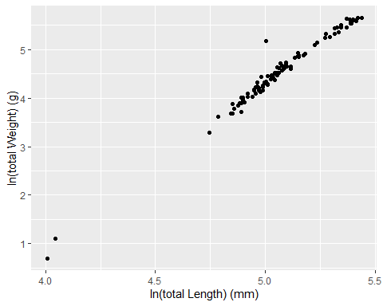

#6. Estimate coefficients of a weight-length model using the “BluegillLM”   
#data set from the FSAdata package. Also determine the 95% confidence intervals for the   
#intercept and slope.  
  
#Estimate parameters of the weight-length model   
#using lm()  
lm1 <- lm(log(wght) ~ log(tl), data=BluegillLM)  
  
#Extract summary information and send to a new object  
sumlw <- summary(lm1)  
sumlw

##   
## Call:  
## lm(formula = log(wght) ~ log(tl), data = BluegillLM)  
##   
## Residuals:  
## Min 1Q Median 3Q Max   
## -0.23515 -0.06560 -0.00255 0.04925 0.85876   
##   
## Coefficients:  
## Estimate Std. Error t value Pr(>|t|)   
## (Intercept) -12.72170 0.26066 -48.81 <2e-16 ***  
## log(tl) 3.40625 0.05139 66.28 <2e-16 ***  
## ---  
## Signif. codes: 0 '***' 0.001 '**' 0.01 '*' 0.05 '.' 0.1 ' ' 1  
##   
## Residual standard error: 0.1166 on 98 degrees of freedom  
## Multiple R-squared: 0.9782, Adjusted R-squared: 0.978   
## F-statistic: 4393 on 1 and 98 DF, p-value: < 2.2e-16

#Extract coefficients and send to a new object  
coeflw <- coef(lm1)  
coeflw

## (Intercept) log(tl)   
## -12.721697 3.406255

#Extract confidence intervals for coefficients  
confinlw <- confint(lm1)  
confinlw

## 2.5 % 97.5 %  
## (Intercept) -13.238967 -12.204427  
## log(tl) 3.304266 3.508244